Handheld FPV Jammer

Model No: TTSKF08

Product Overview
- Efficient Jamming: Adopts advanced signal interference technology to transmit jamming signals on the same frequencies as FPV drone communications, effectively disrupting their communication and navigation functions, causing loss of control or flight failure.
- Portable and Easy Operation: Compact design and lightweight, easy to carry and operate. One-button activation makes it user-friendly.
- Battery Level Display: Clear indication of power level ensures reliable operation during critical moments.
- Multi-Frequency Coverage: Customizable according to customer requirements.
- Full Aluminum Housing: Built-in 24V CPU cooling fan and aluminum casing enhance heat dissipation and system stability.
- Enhanced Protection Mechanism: Integrated VSWR alarm, overcurrent alarm, and overtemperature protection for real-time monitoring of equipment anomalies.

Technical Specifications
Specification | Details
Frequency Bands | 720–850 / 850–930 / 930–1100 / 700–1000 / 2.4GHz / 5.8GHz (optional)
Total RF Output Power | 40W (One band) / 60W (Two bands)
Number of Jamming Modules | 1–2
Protection System | VSWR alarm, overcurrent alarm, overtemperature protection
Jamming Source | Analog signal synthesis technology
Antenna Type | Omnidirectional antenna
Number of Antennas | 1–2
Battery Capacity | 24V / 3.2Ah
Device Dimensions | 200 × 85 × 42 mm
System Weight | Approx. 1.2 kg (main unit without antenna)
Operating Temperature | -30°C to +70°C

Note
The product must use short-circuit structured antennas. Otherwise, the device will not operate.

Operating Instructions
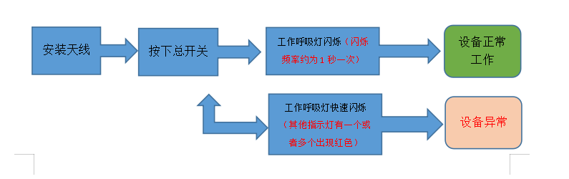

Packing List
Antennas (according to number of frequency bands)
Main Unit ×1
24V Charger ×1
Camouflage Carry Bag ×1

